Introduction

In the end off the 1700-century a fantastic animal arrived to London. It was from the British Empire colony in Australia. The animal had a thick brown waterproof fur. On the hind foot there was spurs and it had webbed feet. But the most characteristic was the beak it had.
It looked as a duckbill. At first many scientists said that it was a fake, made in the Far East. But after a strict examination they changed their mind. The animal was a platypus.

The platypus is considered to be one of the world’s most unusual animals. Many scientists describe it as a living fossil. At first they had trouble with naming it and were they should place it in the big family three. But after a big discussion they placed it in the branch of mammals. Then the platypus can just be find in Australia.

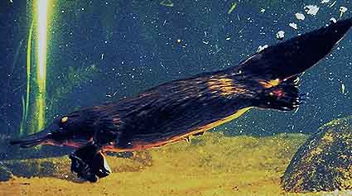

The platypus diving ability:
The maximum time a platypus can be under water is 14 minutes. But usually is the dive time around 3-50 minutes, and after that it returns to the surface to breathe. Primary it dives to search for food. The platypus diet is for the most different insects like water bugs, flies, worms, shrimps and so on. When the platypus dives for food it cover it’s eyes and ears so it can’t hear or see.
Instead the platypus relies on its electroreception system in its beak. That system helps the platypus to detect the small flickers of electricity. Why does it have this electroreception system then? It’s because the platypus hunts under water and for the most at night. In those conditions, hearing and seeing often is useless.

The platypus fur:
The platypus fur is extremely fine and even thicker than the polar-beers coat. Each square millimetre of skin has around 900 hairs- the coat also has two layer of hair. Those layers develop an another layer of air that keeps the body dry, even when it dives.

The body temperature:
A strange thing with the platypus is that its body temperature normally is 32 Celsius degrees. It has this temperature so it not shall lose so much heat to the water, when diving. But the combination of low body temperature and such thick fur means that the platypus very easy become over heated when it is moving on land.

Swimming:
When the platypus swims does it only use its front feet to get forward. The front feet are equipped with large webs of skin. The skin makes the platypus an effective swimmer. The hind legs are used for steering and stabilise the platypus when swimming.

The tail:
The platypus tail is broad and looks like a paddle.
The main function of the tail is to store fat for reserve. But the female can also use her tail to collect leaves. The leaves are used to make a breeding chamber in the burrow.

Reproduction:
The platypus lays eggs. The eggs are produced around late winter or early spring. It is around three eggs the female puts in the breeding chamber. The eggs is leathery shelled just like the reptiles and is also around 15-18 millimetres long. The mother doesn’t just leave her youngsters at once. At first she warming them and give them milk. But platypuses doesn’t have any nipples, instead the rich milk-fat floats out on the mothers hairs and sucks in by the young. The male doesn’t help the mother to raise the children.

Size and life:
The male platypus becomes around 6-8 years old. The female becomes around 4-5 years. And the oldest platypus ever found was 17 years old. The total body length is around 50 centimetres. The usual weight is 1,2-2-6 kilos. But the heaviest platypus found weight 3 kilos. Often the females are a little bit smaller then the males.

Predators:
The worst enemies the platypuses have is hawks and eagles. Water rats and python-snakes may attack young platypuses in their burrows. It has also been reported that crocodiles have attacked platypuses. Then implanted species as foxes, dogs and cats have become a treat for the platypuses.
